PROJECT TITLE: GREENLIGHT-RISK-ENGINE
### A Business Intelligence Solution Driving Data Backed Movie investment
The Greenlight Risk Engine is a predictive business intelligence dashboard designed to evaluate movie viability before capital allocation. By analysing a historical dataset of over 10,000+ movies, this tool minimises financial risk in film investment shifting the executive decision-making process from creative gut-feeling to data-driven probability
--
The problem & Solution
Film production is a multi-million dollar gamble. Historically, executive relied heavily on intuition to greenlight scripts.

This engine provides an objective counterweight: by inputting a proposed budget alongside specific project parameters (genre, language, release season and production company) executives instantly generate an evaluation matrix containing:
- Dynamic Greenlight Risk Score: an aggregated risk index showing overall concept safety,
- Expected ROI Forecasting: Probability-based return distribution matching the target budget profile.
- Historical Failure Rate: Baseline attrition metrics calculated from statistically similar cohorts.
--
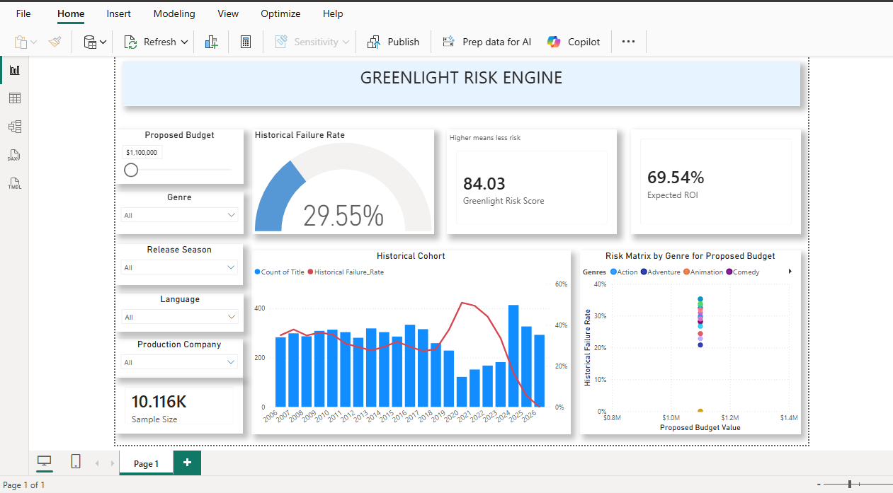
DASHBOARD PREVIEW
--
KEY FEATURES AND ANALYTICAL INSIGHTS
- Risk Threshold Gauge: Dynamically calculates a 29.55% baseline failure rate across the historic sample size
- Executive KPIs: Surfaces a unified
- Greenlight Risk score
- Expected ROI
- Historical failure rate
- Historical Cohort
- Project parameters
- Proposed Budget
- Release season
- Language
- Production Company

Tech Stack Data Processing: Power Query (M)
- Data Modelling/Analytics: Power BI
- Visualization: Power BI
- Dataset source: Kaggle TMDB

Skill demonstrated
ETL process: Using Power Query
Data Modelling: Star schema design joining historical TMDB movie datasets
DAX & Metrics: Advanced conditional logic, calculated measures, and custom time-intelligence parameters.
UI/UX Design: Implemented functional visual hierarchies, custom card formatting, and cohesive muted colour palettes for institutional accessibility
Repository Structure
Dashboard: Contains the native ‘.pbix’ and ‘.pbip’ file
Documentation: Holds high-resolution design assets and screenshots
Data: Information regarding data lineage and transformations
--

